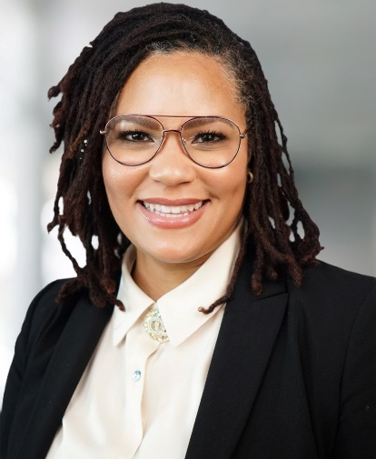
A recognized subject matter expert in organizational development, conflict resolution and civil rights, Jolaina Jeff-Cartier serves as a Senior Staff Associate at the U.S. National Science Foundation (NSF) in Alexandria, Virginia. As a liaison to the scientific community on activities related to Broadening Participation and research capacity in STEM, Ms. Jeff-Cartier acts as an advisor to the White House Initiative on Advancing Educational Equity, Excellence, and Economic Opportunity through Historically Black Colleges and Universities and the Congressional Advisory Committee on Equal Opportunities in Science and Engineering (CEOSE).
Jolaina joined Howard University’s Ph.D. Cohort in Higher Education Leadership and Policy Studies (HELPS) in Fall 2024. She completed her Master’s Degree in Labor & Employment Relations and her Bachelor’s Degree in Psychology at the University of Cincinnati.

